Batch: A2 Roll No.: 16010122034

Experiment No 4

TITLE : To study and implement Non Restoring method of division

AIM : The basis of algorithm is based on paper and pencil approach and the operation involve repetitive shifting with addition and subtraction. So the main aim is to depict the usual process in the form of an algorithm.
______________________________________________________________________
Expected OUTCOME of Experiment: (Mention CO/CO’s attained here)

CO1- Describe and define the structure of a computer with buses structure and detail working
of the arithmetic logic unit and its sub modules

_____________________________________
Books/ Journals/ Websites referred:

- Carl Hamacher, Zvonko Vranesic and Safwat Zaky, “Computer Organization”, Fifth Edition, TataMcGraw-Hill.
- William Stallings, “Computer Organization and Architecture: Designing for Performance”, Eighth Edition, Pearson.
3. Dr. M. Usha, T. S. Srikanth, “Computer System Architecture and Organization”, First Edition, Wiley-India.
_____________________________________________________________________
Pre Lab/ Prior Concepts:
The Non Restoring algorithm works with any combination of positive and negative numbers.

Flowchart for Non Restoring of Division( Students need to draw)
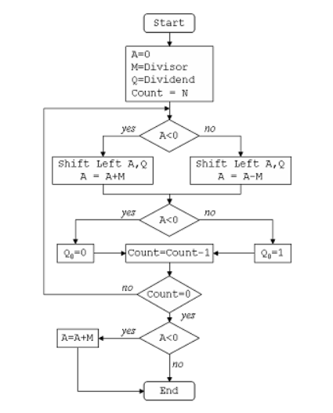

CODE:
#include <stdio.h>
#include <stdlib.h>

void non_restoring_division(int * m, int * q, int size);

int main()
{
int m[] = {0, 0, 1, 0, 0};
int q[] = {0, 1, 0, 0, 1};

int *pm = m;
int *pq = q;
non_restoring_division(pm, pq, 5);

return 0;
}

void non_restoring_division(int * m, int * q, int size){
int * a = (int *)calloc(size, sizeof(int));

printf("m:");
for (int i = 0; i < size; i++)
printf("%d", m[i]);
printf("\ta: ");
for (int i = 0; i < size; i++)
printf("%d", a[i]);
printf("\tq: ");
for (int i = 0; i < size; i++)
printf("%d", q[i]);

// TWOS COMP
int * mcomp = (int *)calloc(size, sizeof(int));
int found_one = 0;
for(int j = 1; j <= size; j++) {
int place = size - j;
int digit = m[place];
if (found_one == 1) {
if(digit == 1)
mcomp[place] = 0;
else
mcomp[place] = 1;
continue;
}
mcomp[place] = m[place];
if (m[place] == 1)
found_one = 1;
}

printf("\nM 2's COMP:\t");
for (int i = 0; i < size; i++)
printf("%d", mcomp[i]);
printf("\n");

for (int i = 0; i < size; i++){
printf("\n------------- CYCLE %d -----------\n", i + 1);
for (int i = 0; i < size; i++)
printf("%d", a[i]);
printf("\t");
for (int i = 0; i < size; i++)
printf("%d", q[i]);
printf("\n");

// LEFT SHIFT
int msb = a[0];
for (int j = 1; j < size; j++){
a[j - 1] = a[j];
}
a[size - 1] = q[0];
for (int j = 1; j < size; j++){
q[j - 1] = q[j];
}

printf("After Left Shift: ");
for (int i = 0; i < size; i++)
printf("%d", a[i]);
printf("\t");
for (int i = 0; i < size; i++)
printf("%d", q[i]);
printf("\n");

if (msb == 1){
q[size - 1] = 0;

// A -> A + M
int c = 0;
for (int j = 1; j <= size; j++){
int p = size - j;
int sum = m[size - j] + a[size - j] + c;
if(sum == 3){
a[size - j] = 1;
c = 1;
}
else if (sum == 2){
a[size - j] = 0;
c = 1;
}
else if (sum == 1){
a[size - j] = 1;
c = 0;
}
else {
a[size - j] = 0;
c = 0;
}
}
printf("After A -> A + M and checking A's sign: ");
}
else{
// A -> A + (-M)
int c = 0;
for (int j = 1; j <= size; j++){
int p = size - j;
int sum = mcomp[size - j] + a[size - j] + c;
if(sum == 3){
a[size - j] = 1;
c = 1;
}
else if (sum == 2){
a[size - j] = 0;
c = 1;
}
else if (sum == 1){
a[size - j] = 1;
c = 0;
}
else {
a[size - j] = 0;
c = 0;
}
}
printf("After A -> A + (-M) and checking A's sign: ");
}

if (a[0] == 0){
q[size - 1] = 1;
}
else{
q[size - 1] = 0;
}

// PRINTING CYCLE
for (int i = 0; i < size; i++)
printf("%d", a[i]);
printf("\t");
for (int i = 0; i < size; i++)
printf("%d", q[i]);

}
if (a[0] == 1){
q[size - 1] = 0;
// A -> A + M
int c = 0;
for (int j = 1; j <= size; j++){
int p = size - j;
int sum = m[size - j] + a[size - j] + c;
if(sum == 3){
a[size - j] = 1;
c = 1;
}
else if (sum == 2){
a[size - j] = 0;
c = 1;
}
else if (sum == 1){
a[size - j] = 1;
c = 0;
}
else {
a[size - j] = 0;
c = 0;
}
}
}

printf("\n\n");
printf("After A -> A + (-M): ");
for (int i = 0; i < size; i++)
printf("%d", a[i]);
printf("\t");
for (int i = 0; i < size; i++)
printf("%d", q[i]);

}
OUTPUT:
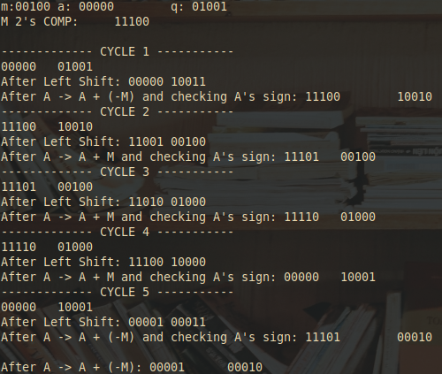

Example: (Handwritten solved problem needs to uploaded)
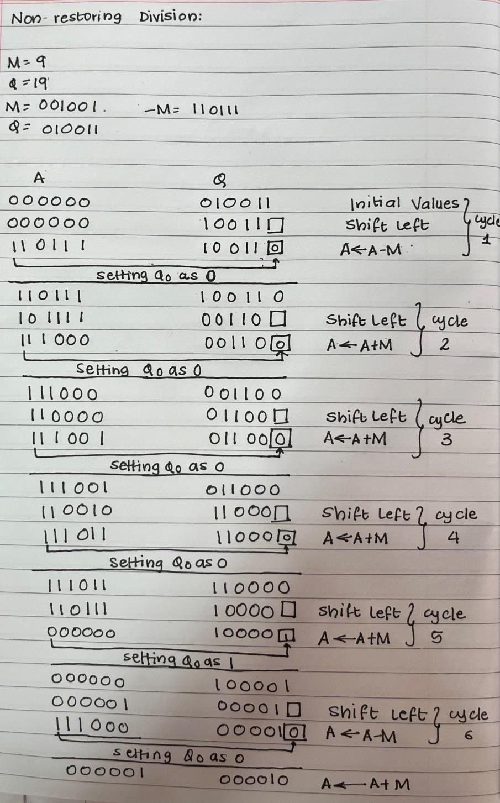

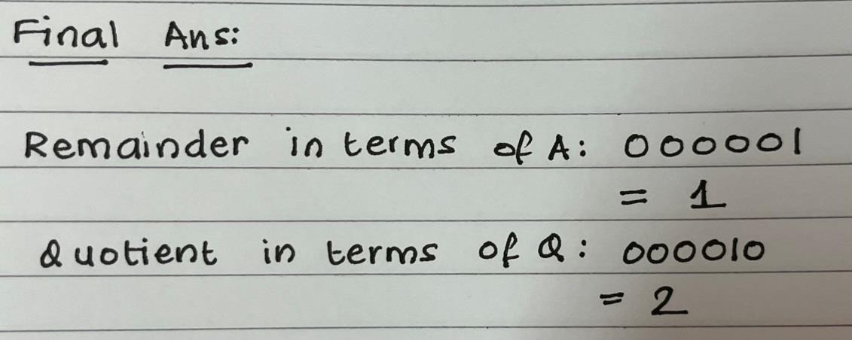

Conclusion
The concept of non-restoring method of division was used to divide two binary numbers and verified.
Post Lab Descriptive Questions
What are the advantages of non restoring division over restoring division?
The advantage of using non-restoring arithmetic over the standard restoring division is that a test subtraction is not required; the sign bit determines whether an addition or subtraction is used.
The non-restoring division algorithm is more complex as compared to the restoring division algorithm. But when we implement this algorithm in hardware, it has an advantage, i.e., it contains only one decision and addition/subtraction per quotient bit. After performing the subtraction operation, there will not be any restoring steps. Due to this, the numbers of operations basically cut down up to half. Because of the less operation, the execution of this algorithm will be fast.

Date: _____________ Signature of faculty in-charge

